**Information Visualization –Programming with D3.js**

**Car Data Insights: A Visual Dashboard**

**Final Report**

**Team Name: FLASHES  
Team Members:**

1. **Swetha Yanamandhalla – 811294573 –** [**syanaman@kent.edu**](mailto:syanaman@kent.edu)
2. **Sai Laxmi Priyanka Gannavarapu – 811283553 –**[**sgannava@kent.edu**](mailto:sgannava@kent.edu)
3. **Ajaychary Kandukuri – 811294510 –** [**akanduk1@kent.edu**](mailto:akanduk1@kent.edu)
4. **Akhil Pathi – 811254719 –** [**apathi@kent.edu**](mailto:apathi@kent.edu)

**Live Dashboard Link:** [**https://gannavarapu-priya.github.io/IV_Project/**](https://gannavarapu-priya.github.io/IV_Project/)

**Git Hub Link:** [**https://github.com/gannavarapu-priya/IV_Project.git**](https://github.com/gannavarapu-priya/IV_Project.git)

**1. INTRODUCTION**

The automotive industry generates an extensive amount of data that reflects the evolution of vehicle performance, design, and market trends over time. Harnessing this data effectively can lead to valuable insights for design optimization, environmental policy, and consumer engagement. This project focuses on building a feature-rich, interactive dashboard using D3.js to visualize and explore historical car data through multiple lenses.

The dashboard enables users to investigate key vehicle attributes such as miles per gallon (MPG), horsepower, weight, cylinder count, and manufacturer origin. It supports a comprehensive exploration through four major visualization tasks: identifying clusters of cars based on performance characteristics, analysing changes in fuel efficiency over time across global regions, understanding the relationship between horsepower and fuel consumption concerning weight, and examining the distribution of cars by manufacturer and origin.

Designed with a diverse user base in mind—including data analysts, engineers, automotive researchers, and environmental policy makers—the system emphasizes usability and visual clarity. Each visualization includes dynamic interaction features like brushing, zooming, and tooltips to enhance data engagement. Users can compare, filter, and interpret large volumes of multivariate data in an intuitive and visually cohesive environment.

The dashboard adheres to best practices in visual design, incorporating principles outlined in the IEEE VIS 2023 heuristics. These principles ensure that the system supports exploration, storytelling, accessibility, and collaborative insight generation. Ultimately, this project demonstrates how interactive data visualization can turn complex datasets into actionable knowledge, enabling a better understanding of automotive trends and data-driven decision-making.

**2. METHODOLOGY AND DATASET**

To build the interactive dashboard, we used a structured methodology that included data preparation, visualization design, interactivity integration, and final deployment. Our process was iterative and guided by user-centered design principles, ensuring the final product is intuitive, functional, and meaningful for various user types.

**Dataset Description:** We used the a1-cars.csv dataset, which contains detailed information about various car models, including key attributes such as MPG (miles per gallon), horsepower, weight, cylinders, acceleration, model year, and origin (e.g., USA, Europe, Japan). The dataset spans vehicles produced primarily during the 1970s and 1980s, offering a rich base for historical trend analysis and comparative evaluation.

**Data Cleaning and Preparation:** Before visualization, the dataset underwent thorough cleaning. Missing or invalid values were either corrected or removed, and categorical fields like "origin" were encoded consistently. Numerical values were normalized where needed to allow fair comparisons across visualizations.

**Visualization Approach:** We adopted a task-driven approach, selecting visual formats that best suit each analytical goal. D3.js was chosen for its flexibility and support for dynamic, web-based data visualizations. Each visual is interactive, ensuring that users can dive deep into the dataset through tools like brushing, zooming, and tooltip inspection.

**Deployment:** The entire system is hosted on GitHub Pages, making it accessible through modern web browsers without requiring installation or downloads. This supports ease of access, feedback collection, and sharing with stakeholders or evaluators.

**3. TASK OVERVIEW**

This project defines four major tasks that explore performance, efficiency, and market trends in the automotive domain. Each task is paired with a suitable visualization to support deeper insight. The tasks include clustering cars by technical specifications, evaluating fuel economy over time, examining the relationship between horsepower and MPG, and assessing manufacturer contributions by region. All visuals are enhanced with interactivity such as brushing, zooming, tooltips, and synchronized views to enrich the analysis experience and guide users through data exploration.

**4. VISUALIZATION TASKS**

**TASK 1: CLUSTER VEHICLES BY PERFORMANCE AND DESIGN ATTRIBUTES**

**Objective:** To uncover patterns among cars based on shared characteristics such as miles per gallon (MPG), horsepower, number of cylinders, and overall weight.

**Visualization Used:** Parallel Coordinates Plot

**Rationale:** The parallel coordinates plot is highly effective for displaying multiple continuous variables at once. Each car is represented as a line moving across vertical axes, with each axis showing a different feature. When lines follow similar paths, clusters become visually apparent, making it easier to detect similarities in performance and design.

**Interactions:**

* **Brushing:** Allows users to select specific ranges on any axis to isolate subsets of vehicles with matching traits.
* **Tooltip on Hover:** Provides real-time details for any selected car, including all its performance metrics.

**Challenges & Solutions:** With many lines, the chart can become cluttered and difficult to interpret. By using brushing and highlighting selected lines, the user can reduce visual noise and focus on relevant data segments.

**Image Suggestion:** Parallel Coordinates Plot with brushing applied and a visible cluster highlighted.

*Caption:* Identifying clusters of cars based on shared performance and design metrics.

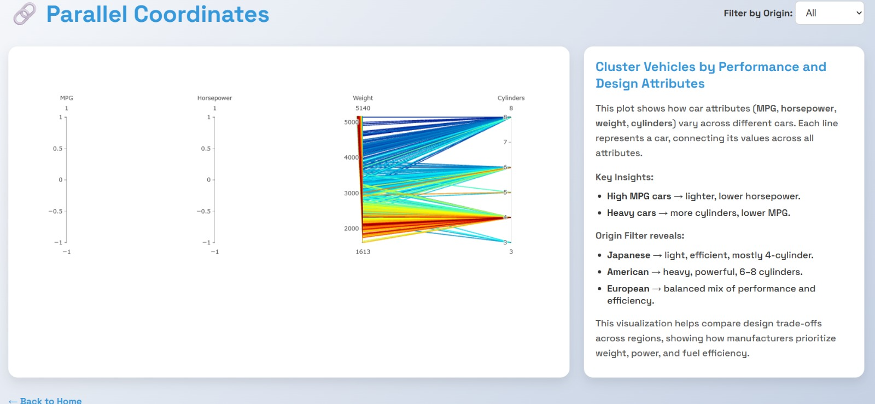

**TASK 2: ANALYZE FUEL EFFICIENCY TRENDS OVER TIME**

**Objective:** To investigate how fuel economy, measured in miles per gallon (MPG), has evolved over different model years, segmented by car origin (USA, Europe, Japan).

**Visualization Used:** Line Chart grouped by Car Origin

**Rationale:** A line chart effectively shows temporal changes. By grouping lines according to region, users can observe which areas led to improvements in fuel efficiency and detect any patterns or declines over time.

**Interactions:**

* **Hover Tooltips:** Display MPG values at each point in time for the selected region.
* **Legend Filters:** Let users show or hide specific origins to focus comparisons.
* **Zooming and Panning:** Help users explore specific year ranges more closely, especially useful when dealing with dense data intervals.

**Image Suggestion:** Line Chart showing distinct MPG trendlines by region.

*Caption:* Evolution of fuel efficiency across American, European, and Japanese vehicles from the 1970s to the 1980s.

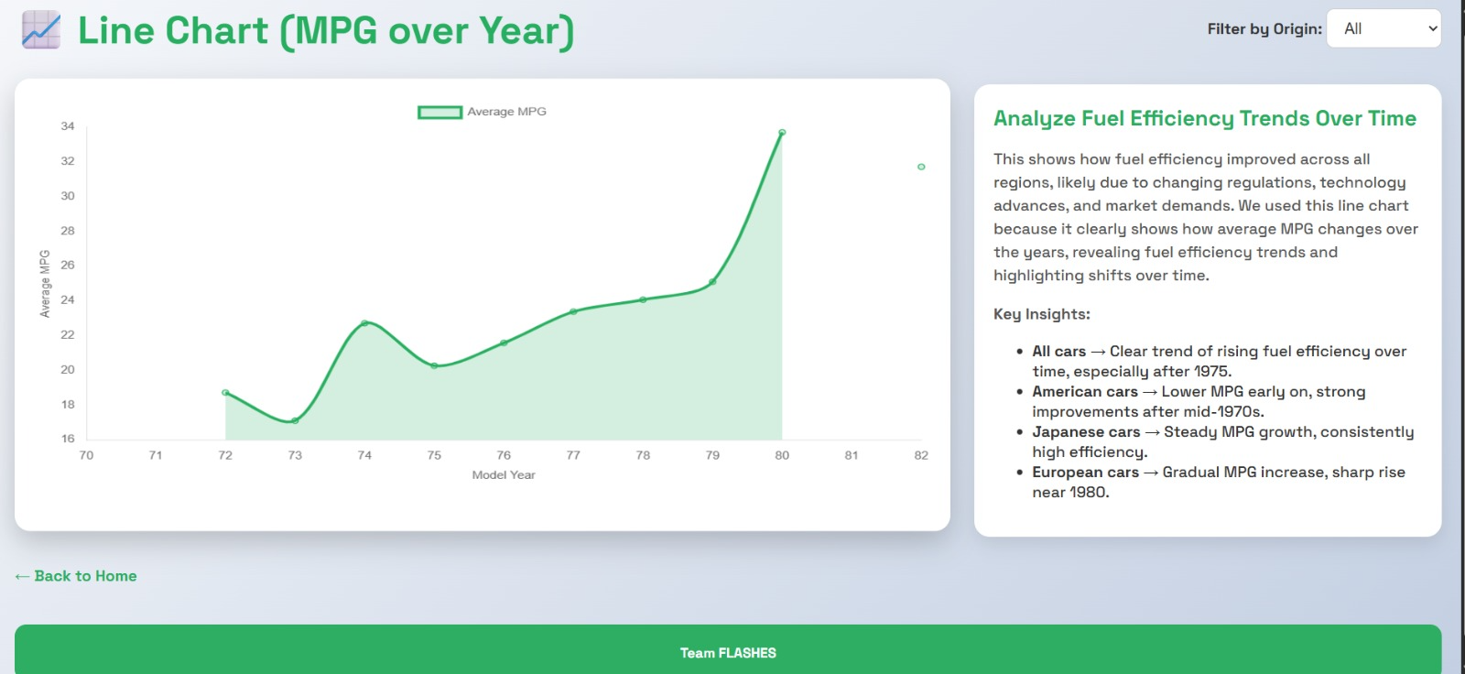

**TASK 3: UNDERSTAND THE RELATIONSHIP BETWEEN HORSEPOWER, MPG, AND WEIGHT**

**Objective:** To analyse how engine power (horsepower) influences fuel efficiency (MPG), and how vehicle weight further affects this relationship.

**Visualization Used:** Scatter Plot with Regression Line

**Rationale:** This chart provides a two-dimensional view where horsepower and MPG are plotted on the x and y axes, respectively. The size of each point indicates vehicle weight, and a regression line helps users quickly see the overall trend, typically an inverse relationship between horsepower and MPG.

**Interactions:**

* **Tooltip on Hover:** Shows detailed values for each vehicle, including name, MPG, horsepower, and weight.
* **Zoom and Pan:** Allow users to narrow in on specific regions of the plot, such as low-efficiency or high-performance segments.

**Challenges & Solutions:** When many data points overlap, it becomes hard to see individual trends. The regression line and zooming interactions provide clarity, while tooltips allow for point-specific detail retrieval.

**Image Suggestion:** Scatter Plot with regression line and selected data point tooltip.

*Caption:* Exploring the balance between engine power and fuel efficiency across car models.

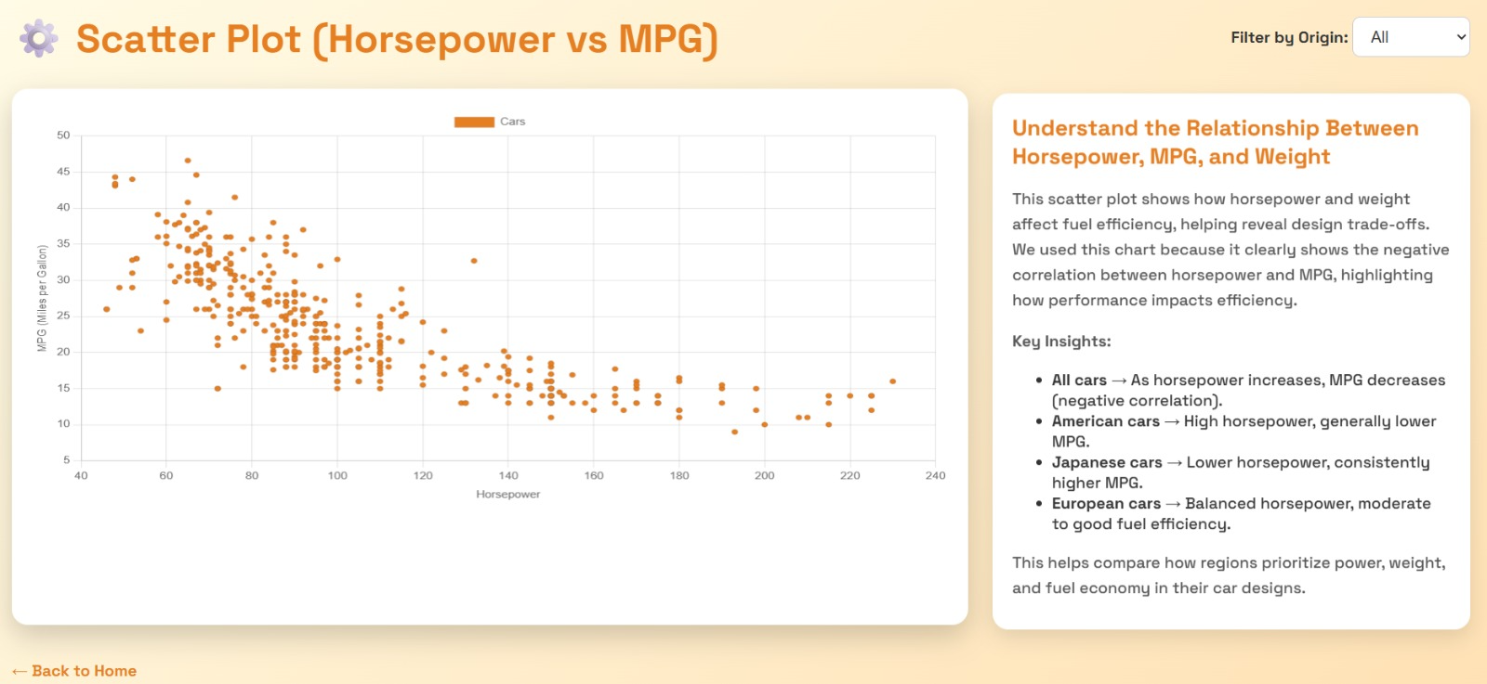

**TASK 4: MANUFACTURER AND ORIGIN-BASED DISTRIBUTION ANALYSIS**

**Objective:** To understand how car production is distributed among manufacturers and how these manufacturers are grouped based on their country or region of origin.

**Visualization Used:** Bar Chart

**Rationale:** A Bar Chart divides a space into nested rectangles where each rectangle represents a manufacturer. The size of each rectangle is proportional to the number of cars, and groups are visually separated by region. This makes it easy to compare production volume and identify major contributors.

**Interactions:**

* **Hover Tooltip:** Shows the manufacturer name and total number of cars represented.
* **Color Coding:** Separates and highlights different regions for clear distinction between origins.

**Challenges & Solutions:** Smaller manufacturers may occupy minimal space, making it hard to read. Tooltips solve this by providing full details without needing large visual real estate.

**Image Suggestion:** Bar Chart with clear origin-based grouping and manufacturer blocks.

*Caption:* Visualizing how car production is distributed across manufacturers and global regions.

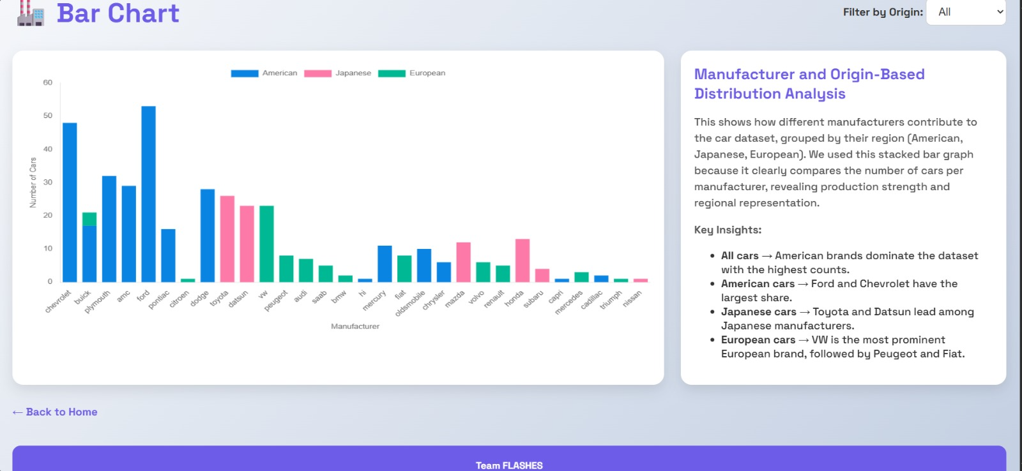

**5. INTERACTION SUMMARY**

The dashboard includes a variety of interactions:

* **Brushing:** For filtering lines and identifying clusters (Task 1)
* **Zoom & Pan:** For deeper inspection (Tasks 2 & 3)
* **Tooltips:** Available across all charts for immediate feedback
* **Coordinated Views:** Filtering or brushing in one chart reflects across others
* **Reset Button:** Allows users to clear filters and restore the original view

These features ensure that users can explore the dataset in a controlled, meaningful way without losing context or clarity.

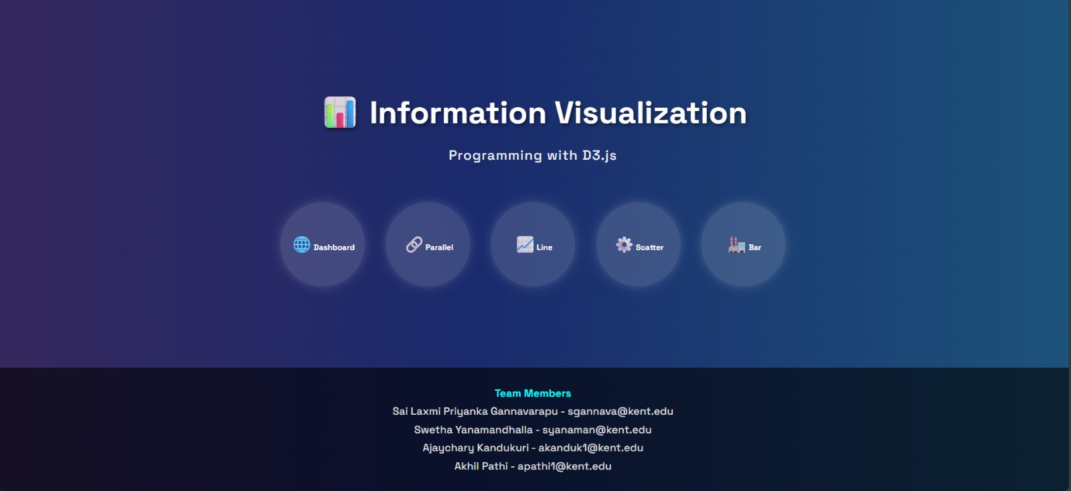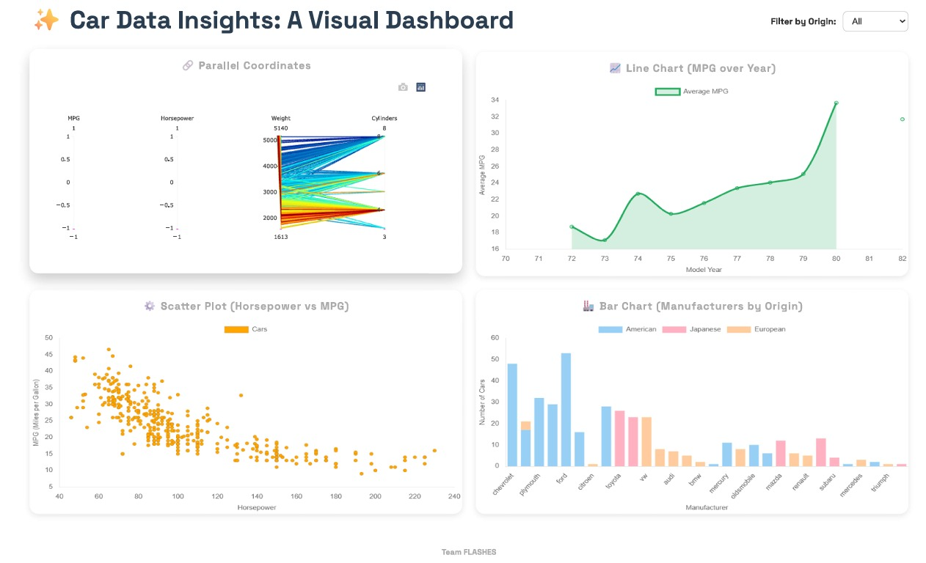

**6. VISUAL DESIGN PRINCIPLES AND ACCESSIBILITY**

In line with IEEE VIS 2023 dashboard heuristics, we ensured the following:

* **Audience Awareness:** Target users include analysts and engineers.
* **Exploratory Support:** Each chart supports comparative and detailed analysis.
* **Storytelling:** Visuals follow a logical narrative from clustering to efficiency to distribution.
* **Accessibility:** Tooltips are screen-reader compatible. High-contrast colors and clear fonts are used.
* **Consistency:** Charts follow a uniform layout and styling for intuitive use.

**7. TOOLS AND TECHNOLOGY STACK**

* **D3.js (v7):** Core visualization library
* **HTML, CSS, JavaScript:** Frontend structure and interactivity
* **GitHub Pages:** Deployment of the live dashboard

All charts are custom-coded using D3 for performance and flexibility.

**8. CONCLUSION**

The Interactive Car Dashboard serves as a comprehensive and intuitive platform for exploring complex automotive data. Through the integration of D3.js and thoughtful interaction design, users can delve into patterns of vehicle performance, trace fuel efficiency changes over time, and assess manufacturer contributions with ease. Each visualization is tailored to a specific analytical task, ensuring clarity and relevance in data interpretation.

This project highlights the power of combining effective data storytelling with dynamic visual tools to support deep exploration. By incorporating interactions such as brushing, tooltips, and coordinated filtering, the dashboard offers a responsive and engaging user experience that adapts to diverse analytical needs.

Moreover, the adherence to visualization best practices and accessibility principles ensures that the system is usable by a broad audience, including researchers, engineers, and policymakers. In conclusion, this dashboard not only presents historical car data but also transforms it into meaningful insights that aid in informed decision-making, design optimization, and automotive innovation.

**9. INDIVIDUAL CONTRIBUTION**

**Swetha Yanamandhalla – 811294573**

Swetha played a pivotal role in designing and developing the **Parallel Coordinates Plot**, which visualizes clusters of cars based on key performance attributes such as MPG, horsepower, weight, and number of cylinders. She was responsible for data cleaning, normalization, and formatting specifically to support high-dimensional multivariate plotting. Swetha also implemented key interactive elements such as **brushing and tooltips**, ensuring smooth user interaction. In addition, she contributed to the overall visual styling of the dashboard, worked collaboratively on layout consistency, and supported final report compilation.

**Sai Laxmi Priyanka Gannavarapu – 811283553**

Priyanka spearheaded the creation of the **Line Chart** focused on analysing fuel efficiency trends over time across car origins (USA, Europe, Japan). She designed the chart logic using D3.js, implemented zooming and pan functionalities, and added region-specific groupings for comparison. She also integrated tooltip interactions and filter options through the legend. Beyond visualization, Priyanka handled **deployment via GitHub Pages**, ensuring the dashboard was responsive, accessible, and functional across different devices and screen sizes. She also supported team collaboration via version control.

**Ajaychary Kandukuri – 811294510**

Ajaychary led the development of the **Scatter Plot with Regression Line**, designed to examine the relationship between horsepower, MPG, and vehicle weight. He implemented the plot logic from scratch, integrating a **regression line** to reveal overarching trends and supporting **zoom and pan** interactions for granular exploration. Ajaychary fine-tuned the **tooltip functionality** to present rich, contextual insights for each vehicle, including dynamic markers that reflect weight variations through point sizing. Beyond the individual visualization, he contributed significantly to optimizing the D3.js codebase and ensuring modular, reusable script components throughout the dashboard project.

**Akhil Pathi – 811254719**

Akhil developed the **Manufacturer - Origin Distribution Bar Chart**, which visually maps car manufacturers across regions using size-coded blocks. He structured the visualization to reflect manufacturer output and regional grouping clearly and accessibly. Akhil integrated interactive tooltips and region-specific color encoding for user-friendly navigation. He also helped manage the **data mapping for origin and manufacturer categories**, ensuring consistency across the visualization. Additionally, he contributed to ensuring the final dashboard met the IEEE VIS 2023 heuristic standards for accessibility and design.